OHIO 2004 TELECOMMUNICATOR OF THE YEAR
TRICIA SNYDER
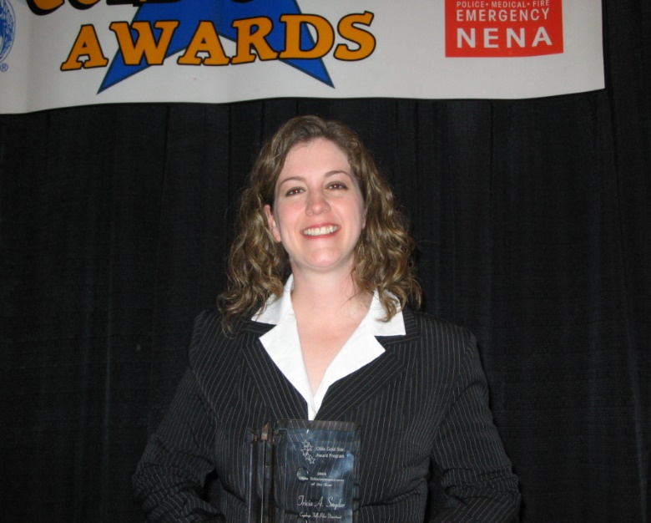
CITY OF CUYAHOGA FALLS POLICE DEPARTMENT

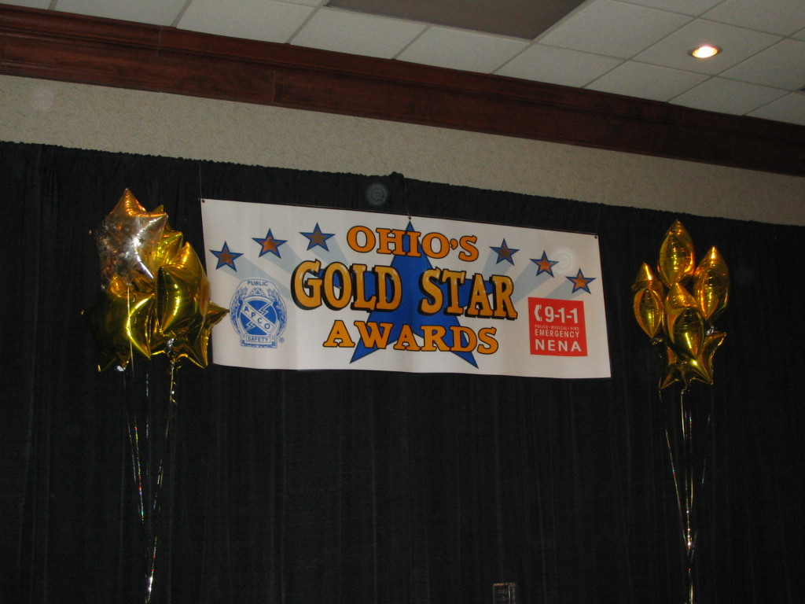
6th Annual Gold Star Awards Luncheon
April 13,2005
Worthington, Ohio

Ohio Gold Star Award Program

Hosted by the Ohio Chapters of NENA and APCO
Program
• Opening
Mr. Jay Somerville, President Ohio Chapter of APCO, Communications Supervisor, City of Dublin Police Communications
• Presentation of Colors
City of Wooster Police Department Honor Guard
National Anthem — Mr. Mel Meloy, Fairfield County Sheriffs Office
• Invocation
Sergeant Craig Hungler, Dublin Division of Police
• Lunch
• Introduction of Keynote Speaker
Mr. William Hinkle, Director of Hamilton County Communications Center
• Keynote Speaker
State Representative Larry L. Flowers, Fairfield County

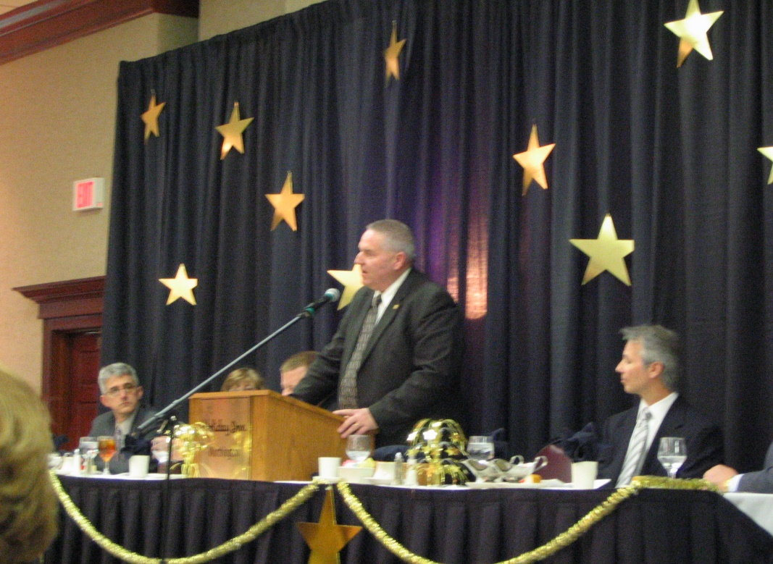

• Sponsor Recognition
Mr. Greg Wenz, Chair - Ohio Gold Star Awards Program, Operation Director—Hamilton County Communications Center
• Award Presentations— Mr. Jay Somerville, Emcee
Awards:
Gold Star Certificates
Double Gold Award - Dispatch Teams
Solid Gold - Ohio Telecommunicator of the Year
• Benediction Sergeant Craig Hungler
• Closing
“God Bless America” Mr. Mel Meloy, Communications Supervisor Fairfield County Sheriffs Office
Seated at the Head Table: Sergeant Craig Hungler. Carol Armitage, Jay Somerville, Representative Larry Flowers, William Hinkle, Greg Wenz
We welcome you to the 2004 Gold Star Awards Program. It is with great pleasure that the Ohio Chapters of APCO and NENA welcome the recipients of the Gold Star Awards and their guests. All of the nominees should feel honored and everyone is a winner. Making a selection of this type is very difficult since all the Telecommunicator in the State do an outstanding job every single day. Every Telecommunicator has handled calls during the year that would be award winning. Additionally, the service they provide to the public on a daily basis makes everyone in the State of Ohio a winner.
We extend a special thanks to the 2004 Gold Star Awards Committee who has worked hard to prepare for today’s event. They have devoted much time and energy to make this special recognition a success. We thank the supervisors and administrators for all the superb nominations that they offered.
We also want to acknowledge the corporate sponsors for their generous financial support of the Gold Star Program, as well as for their continuous support for APCO and NENA.
To all the nominees, on behalf of NENA and APCO, we offer our sincere congratulations, appreciation, and thanks for jobs well done.
Sincerely,
Carol Armitage President, Ohio Chapter NENA

Jay Somerville President, Ohio Chapter APCO

Ohio NENA Board  President  Carol Armitage, Defiance County Communications  Vice President  Wanda Steiner, City of Akron  Secretary  Monte Diegel, Mercer County Sheriff’s Office Central Dispatch  Treasurer  Valerie DeRose, Summit County Emergency Management | Ohio Chapter of APCO. Executive Board  President  Jay Somerville, Dublin Division of Police  1st Vice President  Holly E. Wayt City of Westerville Communications  ₂nd Vice President  Matt Franke, City of Oxford Police  Secretary/Treasurer  Danielle J. Klavinger, Lucas County Emergency Services  Executive Council Representative  Lynne Feller, Wayne County Justice Center
The Gold Star Awards committee would like to thank the following people for their support and participation in the program.
State Representative Larry Flowers
The City of Wooster Police Department Honor Guard
Sergeant Craig Hungler
Mr. Mel Meloy
The Gold Star selection committee
Mr. Jay Somerville
Ms. Carol Armitage
Mr. Mike Banks
Ms. Valerie DeRose

2004 Gold Star Certificates
Dispatcher Shirley Bundschu, Canfield Police Department
Dispatcher Tracy Clark, Grove City Police Department
Radio Dispatcher Jill Erhardt, OSHP Bucyrus Post
Training Coordinator Mory Fuhrmann, Mifflin Township Division of Fire, Metropolitan Emergency Communicatons Center
Dispatcher Margaret Frederick, Whitehall Division of Police
Dispatcher Teresa Gladden, Delaware Police Department
Communications Officer Amber Guthrie, Athens Police Department
9-1-1 Dispatcher Patricia Hunkler, Fairfield Police Department
Telecommunicator Richie Kilgour, Fulton County 9-1-1
Communications Technician Connie Laveck, Lancaster Police Department
Radio Dispatcher Rhonda Macarthy, OSHP Berea Post
Communications Technician Mike Pineault, Dublin Police Communications
Radio Dispatcher Catherine Routte, OSHP West Jefferson Post

2004 Double Gold Awards

Team Award winner

Hamilton County Communications Center

Communications Officers:

Jackie Bray

Denise Brown

Patty Craven

Shawn Cruze

Dawn Koking

Matt Knutson

Andy Moore

Keith Phillips

Joe Siefert

Valerie Seikman

Don Smith

Amber Young

For skilled management, compassion and extra effort during a search for a confused and disoriented motorist experiencing an insulin reaction on December 9, 2004. The team used what little information they had to finally locate the driver about 10 miles from where they thought he was based on cell tower data. Communications Officer Koking continued to search when she was off duty. The caller was transported to the hospital where he recovered.

Nominee’s

Clermont County Communications Center

Dispatchers:

Anita Brill

Dave Chaney

Dominick Daulton

Tonya Goodman

Debbie Hamm

Pam Iker

Ron Kyer

Jim Lungmus

Stacy McCue

Cindy Moermand

Jason Noonan

Richard Pierce

Melissa Scalf

Mabel Sheppard

Steve Weber

Supervisors:

Galen Williams

Brenda Durham

Barb Davis

Fairfield County Sheriff’s Office

Dispatchers:

Angela Fleming

Elizabeth Maple

Melissa Mock

Davita Willis

Fairfield Police Department

9-1-1 Dispatcher Lori Baughman

9-1-1 Dispatcher John Meyer

Mifflin Twp. Division of Fire, Metropolitan Emergency Communications Center

Dispatchers:

Stan Broadway

Mory Fuhrmann

Matt Ruthers

Susan Wilson

North Central EMS

Emergency Medical Dispatcher Chris Cammalleri

Emergency Medical Dispatcher/Paramedic Tommy Johnson

Northeast Communications Center

Dispatchers:

Les Allen

Melissa Kyer

Harry Lofland

Jody Pettyjohn

Lorna Rose

Chris Skinner

Jennifer Spradlin

2004 Solid Gold Award
Ohio Telecommunicator of the Year

Communications Operator Tricia Snyder
City of Cuyahoga Falls Police Department
For exceptional skill getting a 9 year old to safety following a double homicide that he witnessed
Nominees:
Radio Dispatcher Gricel Camacho, OSHP Dayton Post
Radio Dispatcher Karen Collins, OSHP Communications Center
Communications Specialist Nancy Coppock, Miami Township Police Department
Chief Dispatcher Pat Emrisko, Newburgh Heights Police Department
Public Safety Dispatcher Sharon Jeziorski, North Olmstead Police Department
Radio Dispatcher Pamela Kelly, OSHP Xenia Post
Dispatcher Bridget Lahowe, Lakewood Police Department
Communications Officer Mary Lute, Hancock County Sheriff’s Office
Radio Dispatcher Dane Mowen, OSHP Dayton Post
Radio Dispatcher Rhonda Noblick, OSHP Granville Post
Dispatcher/Clerk Nadean Peger, Olmstead Falls Police Department
Call Taker Kathy Price, Delaware County 9-1-1
Radio Dispatcher Davius Reichelderfer, OSHP Marion Post
Dispatcher Rachel Sullivan, Van Wert Police Department
Dispatcher Catherine Wiltrout, Strongsville Police Department

Gold Star Awards Supporting Sponsors
The Gold Star Committee is extremely grateful to these companies for their sponsorship of the Ohio Gold Star Awards Program. Their generosity allows the recognition of our Ohio heroes. Thank you very much.

Emergitech
Gifts for Nominee’s

Motorola
Nominee’s shirts

Intrado
Nonspecific contribution

SBC
Nonspecific contribution

The following vendors also provided items for the nominee’s

B & C Communications
Motorola, Inc.
Reverse 9-1-1
Emergitech

