8th Annual Gold Star Awards Luncheon
Today’s Program
March 28, 2007

Opening
Ms. Holly Wayt, ENP, President Ohio Chapter of APCO
Communications Manager, City of Westerville

Honor America
Posting of the Colors – Wayne County Sheriff’s Office Honor Guard
National Anthem – Mr. Mel Meloy, ENP
Communications Supervisor, Fairfield County Sheriff’s Office

Invocation
Dublin Police Chaplain Steve Norden
New Hope Church in Powell, Ohio

Lunch

Introduction of Keynote Speaker
Mr. William Hinkle
Director, Hamilton County Communications Center

Keynote Speaker
Mr. Peter D. Banks
Director of Training and Outreach for the National Center for Missing & Exploited Children

Sponsor Recognition
Mr. Greg Wenz, ENP, Chair - Ohio Gold Star Awards Program,
Operation Director—Hamilton County Communications Center

Award Presentations—
Mr. Jay Somerville, Emcee
Technical Services Bureau Commander, City of Dublin Police Communications

Awards Presenter: Representative Larry L . Flowers, Franklin County
Awards:
Gold Star Certificates
Double Gold Awards - Dispatch Teams
Solid Gold Awards-
2006 Ohio Telecommunicator of the Year Award

Benediction
Chaplain Steve Norden

Closing
“God Bless America” Mr. Mel Meloy, Communications Supervisor Fairfield County Sheriff’s Office

Seated at the Head Table: Chaplin Steve Norden, Monte Diegel, Holly Wayt, Mr. Peter Banks, William Hinkle, Representative Larry Flowers

Thank you all for attending. We welcome you to the 2006 Gold Star Awards Program. It is with great pleasure that the Ohio Chapters of NENA and APCO welcome the recipients of the Gold Star Awards and their guests. We are extremely proud of each nominee and the work they do every single day. Making a selection of this type is very difficult since all the telecommunicators in the State do an outstanding job. Every telecommunicator has handled calls during the year that would be award winning. Additionally, their dedication and the service they provide to the public on a daily basis makes everyone in the State of Ohio a winner.
We extend a special thanks to the 2006 Gold Star Awards Committee who have worked hard to prepare for today’s event. They have devoted much time and energy to make this special recognition a success. We thank the supervisors and administrators for all the superb nominations that they offered.
We also want to acknowledge the corporate sponsors for their generous financial support of the Gold Star Program, as well as for their continuous support for Ohio NENA and APCO.
To all the nominees, on behalf of NENA and APCO, we offer our sincere congratulations, appreciation, and thanks for jobs well done.

Sincerely,
Monte Diege Holly Wayt
Monte Diegel Holly Wayt
President, President,
Ohio Chapter NENA Ohio Chapter APCO

Ohio NENA Board

President
Monte Diegel, Mercer County Sheriff’s Office Central Dispatch

Vice President
Kim Brandt, Van Wert County 9-1-1

Secretary
Rose Chambers, Wood County Sheriff’s Office

Treasurer
Valerie DeRose, Summit County Emergency Management

Ohio Chapter of APCO, Executive Board

President
Holly E. Wayt, City of Westerville Communications

1st Vice President
Matt Franke, City of Oxford Police

2nd Vice President
Mel Meloy, Fairfield County Sheriff’s Office

Secretary/Treasurer
Danielle J. Klavinger, Lucas County Emergency Services

Executive Council Representative
Lynne Feller, Wayne County Justice Center

The Gold Star Awards committee would like to thank the following
people for their support and participation in the program.
Mr. Peter D. Banks
State Representative Larry Flowers
Chaplain Steve Norden
Mr. Mel Meloy

The Gold Star Selection Committee
Ms. Holly Wayt
Mr. Monte Diegel
Mr. Jay Somerville
Mr. Brad Brubaker

Ohio’s Gold Star Award Program for
Telecommunicators

The Ohio Chapters of the National Emergency Number Association (NENA) and the Association of Public-Safety Communications Officials, International (APCO) have worked together to recognize the outstanding work performed by public-safety communications personnel in Ohio. A few years ago both Chapters saw a critical need for some positive recognition and acknowledgement of the fine work that is performed by the State’s communications professionals. Our goal was to publicly express appreciation, and to recognize both outstanding individual and team performance and consistent, steadfast leadership. Both of the Chapters are proud to present The Ohio 9-1-1 Gold Star Awards program. Because Telecommunicators work in the background, behind the lights, sirens and cameras, they are sometimes overlooked for their critical role in public safety. APCO and NENA have worked in concert to promote and recognize outstanding performance in the dispatch centers around Ohio. Thank you for joining us today to show your appreciation for these dedicated and hard working individuals.

The Gold Star Award Committee

2006 Gold Star Certificates

Highway Patrol Dispatcher Robin S. Case
Ohio State Highway Patrol, Medina Post

Highway Patrol Dispatcher Coleen Foss
Ohio State Highway Patrol, Ashland Post

Highway Patrol Dispatcher Pamela J. Hershberger
Ohio State Highway Patrol, Marion Post

Dispatch Supervisor Doug Houtz
Wood County Sheriff’s Office

Highway Patrol Dispatcher Erica Lanning
Ohio State Highway Patrol, Lancaster Post

Highway Patrol Dispatcher Scott A. Robenalt
Ohio State Highway Patrol, Norwalk Post

Highway Patrol Dispatcher Jennifer J. Scott
Ohio State Highway Patrol, Bucyrus Post

Dispatcher Kris Vitale
Fairfield Police Department

Highway Patrol Dispatcher Terry L. Whitlock
Ohio State Highway Patrol, Fremont Post

Highway Patrol Dispatcher Kevin A. Yoder
Ohio State Highway Patrol, Wooster Post

2006 Double Gold Awards

TEAM AWARD WINNERS

Ohio State Highway Patrol, Findley & Walbridge Posts

Highway Patrol Dispatcher Denise L. Duerk
Highway Patrol Dispatcher Cheryl L. Babione

Wood County Sheriff’s Office

Dispatch Supervisor Nancy Hurst
Dispatcher Paulette Badgett

For outstanding performance March 25, 2006 during an incident that began as a fake ID situation that evolving to shots fired, a person thrown out of a vehicle, pursuit, car jacking, kidnapping and an exchange of gun fire between officers and suspects.

Nominees:

Delaware Police Department
Dispatcher Teresa Gladden
Dispatcher Judy Fitzgerald
Dispatcher Kimberly Romero-Curren

Loudonville Police Department
Dispatcher Sharon Strimple
Dispatcher Melnee Kitchen
Dispatcher Jennifer Hatfield
Dispatcher Jennifer Pearce

Fairfield County Sheriff’s Office
Dispatcher Joe Morris
Dispatcher Beth Whipple
Dispatcher Melissa Locke

Van Wert Police Department and Van Wert County Sheriff’s Office
Communications Officer Cathy Evans
Communications Officer Rachel Sullivan

2006 Solid Gold Award

OHIO 2006 TELECOMMUNICATOR OF THE YEAR

Co-Winners

E911 Operator Jeffrey Bradley
Cincinnati Police Communications

January 14, 2006 For taking the time and extra effort to locate a 911 caller who was at the scene and witnessed a fatal shooting

Highway Patrol Dispatcher Sharon Collins
Ohio State Highway Patrol – Columbus Communications Center

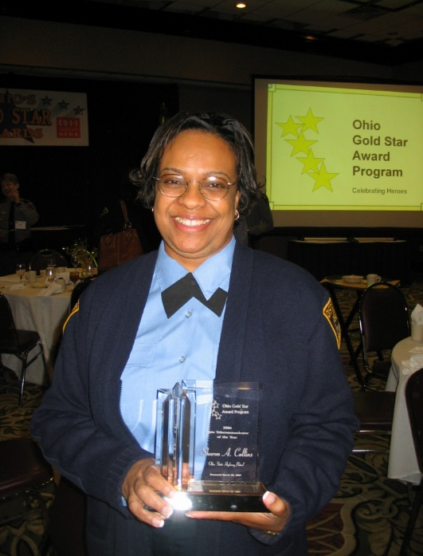

November 7, 2006 For professional and expertly handling a unique situation involving a subject on a Greyhound bus with a loaded gun.

Nominees:

Communications Officer Rod Smith
Van Wert County Sheriff’s Office

Highway Patrol Dispatcher Brian Gettinger
Ohio State Highway Patrol, Toledo Post

Highway Patrol Dispatcher Michelle D. Higgins
Ohio State Highway Patrol, Warren Post

Dispatcher Christina Daniels
Oregon Police and Fire

Gold Star Awards Supporting Sponsors

The Gold Star Committee is extremely grateful to these companies for their sponsorship of the Ohio Gold Star Awards Program. Their generosity allows the recognition of our Ohio heroes. Thank you very much.

AT&T

DDTI, Inc.

EmergiTech

Intrado

Time Warner Cable

Today’s Lunch Includes:
Garden Salad and Bread
Grilled Petite Filet Mignon
Caramelized Shallots and Cognac Demi Glace
Yukon Garlic Mash
Tobacco Onions
New York Cheese Cake with Fresh Strawberries
or
Chocolate Indulgence Cake with Raspberry Coulis and Chocolate Sauce

