9th Annual Gold Star Awards Luncheon Program

Opening
Mr. Jay Somerville, ENP,
Technical Services Bureau Commander, City of Dublin.

Honor America
Posting of the Colors – Westerville Division of Fire Honor Guard 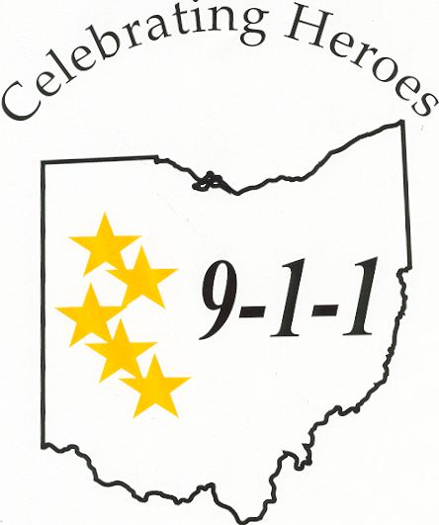
National Anthem—Mr. Mel Meloy
Communications Supervisor, Fairfield County Sheriff’s Office

Invocation
Steve Norden, Dublin Police Chaplain
New Hope Church in Powell, Ohio

Lunch

Introduction of Keynote Speaker
Mr. Jay Somerville, ENP

Keynote Speaker
Lieutenant Susan M. Rance-Locke
Ohio State Highway Patrol

Sponsor Recognition
Mr. Greg Wenz, ENP- Chair - Ohio Gold Star Awards Program,
Operations Director—Hamilton County Communications Center

Award Presentations
Mr. Jay Somerville, ENP, Emcee

Awards Presenter:
Mr. Jay Somerville, ENP

Awards:

Gold Star Certificates

Double Gold Awards - Dispatch Teams

Solid Gold Awards - 2007 Ohio Telecommunicator of the Year Award

Benediction
Chaplain Steve Norden

Closing

“God Bless America” Mr. Mel Meloy

Seated at the Head Table:
Chaplin Steve Norden, Kim Brandt, Jay Somerville, Lieutenant Susan M. Rance-Locke, Holly Wayt, Greg Wenz

Thank you all for attending. We welcome you to the 2007 Gold Star Awards Program. It is with great pleasure that the Ohio Chapters of NENA and APCO welcome the recipients of the Gold Star Awards and their guests. We are extremely proud of each nominee and the work they do every single day. Making a selection of this type is very difficult since all the telecommunicators in the State do an outstanding job. Every telecommunicator has handled calls during the year that would be award winning. Additionally, their dedication and the service they provide to the public on a daily basis makes everyone in the State of Ohio a winner.
We extend a special thanks to the 2007 Gold Star Awards Committee who have worked hard to prepare for today’s event. They have devoted much time and energy to make this special recognition a success. We thank the supervisors and administrators for all the superb nominations that they offered.
We also want to acknowledge the corporate sponsors for their generous financial support of the Gold Star Program, as well as for their continuous support for Ohio NENA and APCO.
To all the nominees, on behalf of NENA and APCO, we offer our sincere congratulations, appreciation, and thanks for jobs well done.

Sincerely,
Holly Wayt Kim Brandt
Holly Wayt, ENP Kim Brandt
President, President,
Ohio Chapter APCO Ohio Chapter NENA

Ohio Chapter of APCO, Executive Board

President
Holly E. Wayt, ENP - City of Westerville Communications

1st Vice President
Matt Franke, City of Oxford Police Department

2nd Vice President
Michael P. Banks, RPL - Wadsworth Police Department

Secretary/Treasurer
Danielle J. Klavinger, ENP - Lucas County Emergency Services

Executive Council Representative
Lynne Feller, Wayne County Justice Center

Ohio Chapter of NENA Board

President
Kim Brandt, Van Wert County 9-1-1

Vice President
Rose Chambers, Wood County Sheriff’s Office

Secretary
Anne Barr, RPL - Union County Sheriff’s Office

Treasurer
Valerie DeRose, Summit County Emergency Management

The Gold Star Awards committee would like to thank the following
people for their support and participation in the program.

Lieutenant Susan M. Rance-Locke
Chaplain Steve Norden
The Westerville Division of Fire Honor Guard
Mel Meloy
Jay Somerville

The Gold Star Selection Committee

Ms. Holly Wayt
Mr. Monte Diegel
Mr. Jay Somerville
Ms. Anne Barr

Ohio’s Gold Star Award Program for
Telecommunicators

The Ohio Chapters of the Association of Public-Safety Communications Officials, International (APCO) and the National Emergency Number Association (NENA) have worked together to recognize the outstanding work performed by public-safety communications personnel in Ohio. Both Chapters see a critical need for positive recognition and acknowledgement of the fine work that is performed by the State’s communications professionals. Our goal is to publicly express appreciation, and to recognize both outstanding individual and team performance and consistent, steadfast leadership in public-safety communications. Both of the Chapters are proud to present The Ohio 9-1-1 Gold Star Awards program. Because Telecommunicators work in the background, behind the lights, sirens and cameras, they are sometimes overlooked for their critical role in public safety. APCO and NENA have worked in concert to promote and recognize outstanding performance in the dispatch centers around Ohio. Thank you for joining us today to show your appreciation for these dedicated and hard working individuals.

The Gold Star Award Committee

2007 Gold Star Certificates

Communication Technician Kimberly Bugbee-Conrad
Lancaster Police Department

Police Communications Technician Lisa Lazar
Columbus Division of Police

Dispatcher Deputy Michelle (Shelly) Vajen
Wood County Sheriff’s Office

2007 Double Gold Awards

TEAM AWARD WINNERS

Westerville Communications Division
Communications Technicians Claudia Estepp
Communications Technicians Susan Vargo
Communications Technicians Marcy Ross
Communications Technicians Julie Ruzicska
Communications Technicians Amy Dent
Communications Technicians Steve Morlan
Dispatcher Gretchen McElroy – Marion City PD

For superb interagency teamwork apprehending a kidnapping
suspect and the safe return of the victim, August 8, 2007

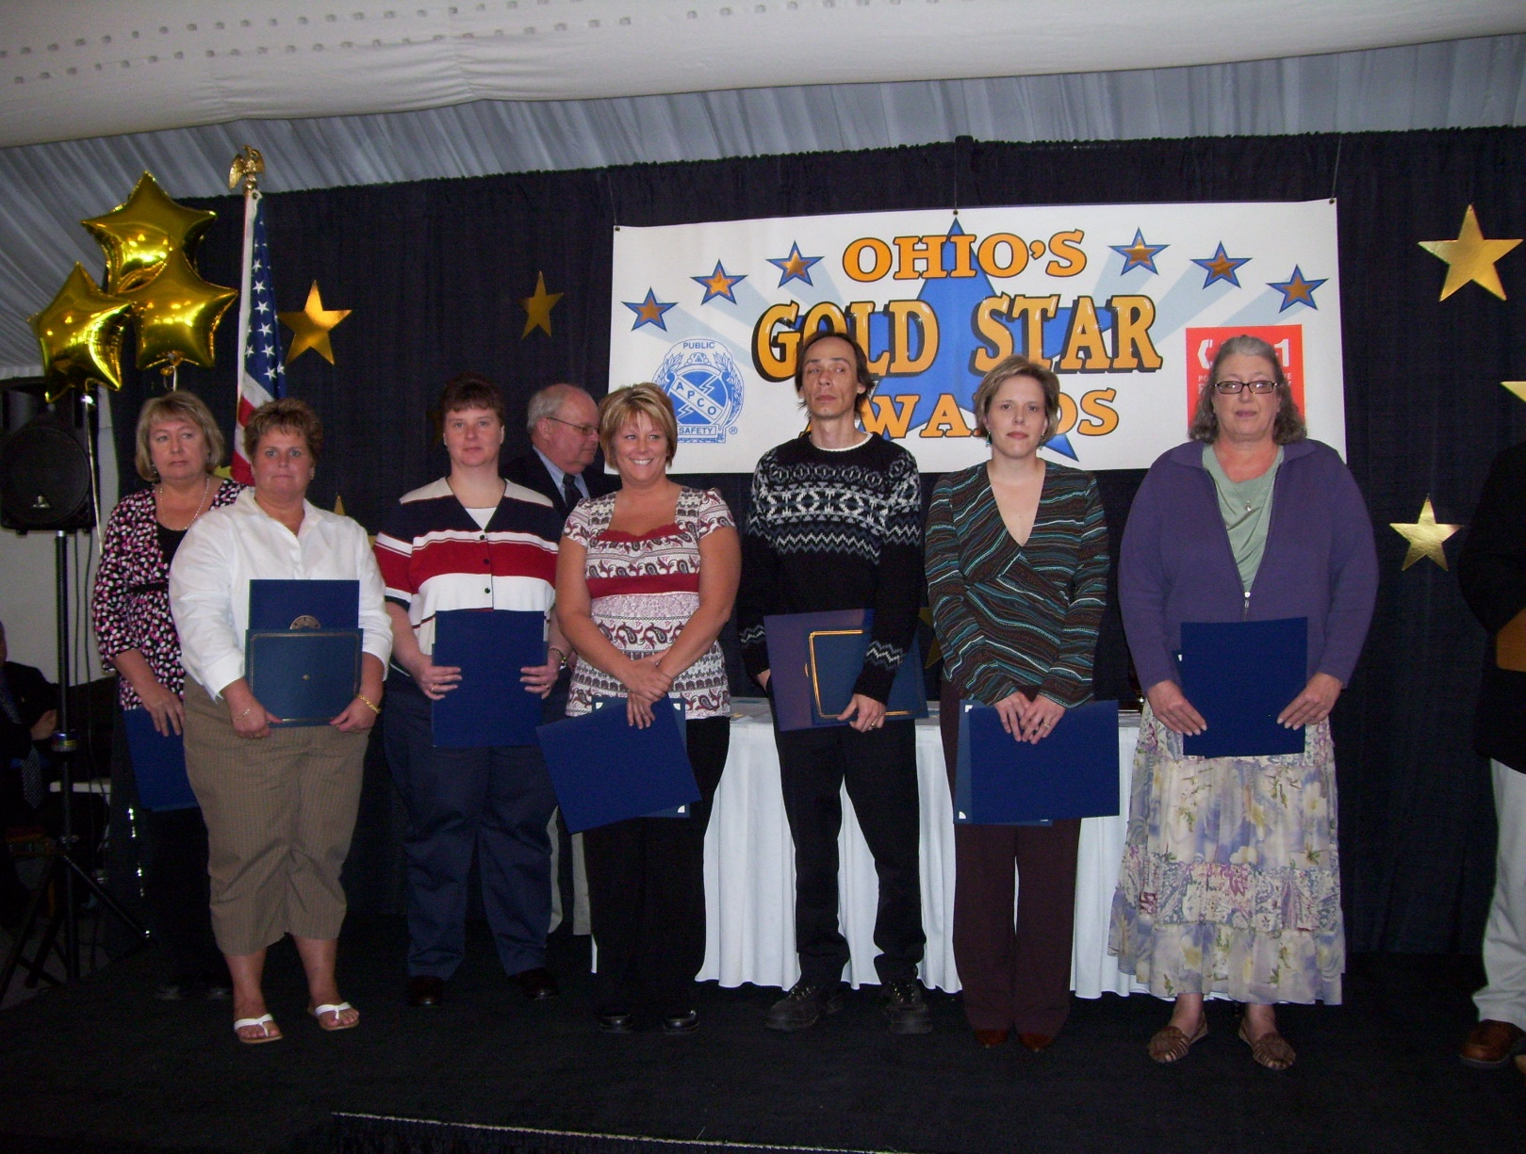

Nominees:

City of Cleveland, Bureau of Communications
Police Radio Dispatcher Andria Cabaniss Police Radio Dispatcher Terrence Chavis
Police Radio Dispatcher Patricia Cross Police Radio Dispatcher Toni Fleetwood
Police Radio Dispatcher Terri Robinson

Lakewood Police Department
Dispatcher Anna Kluiber Dispatcher Jamie Kappa

Lancaster Police Department & Pickerington Police Department
Communication Technician Christy L. Sutphen Public Safety Dispatcher Melanie Large
Communication Technician Stacy England Public Safety Dispatcher Davita Willis

Muskingum County Sheriffs Office
Communications Officer Joleen Kinsel Communications Officer Jaime Swingle

Putnam County Sheriff’s Office 9-1-1

Telecommunicator Tonya Amstutz Telecommunicator Abbot Carder
Telecommunicator Todd Closson Telecommunicator Dave Herring
Telecommunicator Ali Hoffman Telecommunicator Nancy Hovest
Telecommunicator Sara Pedrosa Telecommunicator Heather Schellenbarger
Telecommunicator Mike Schroth Telecommunicator Laura Schwarzman
Telecommunicator Sue Williams

Toledo Police Department Communications Bureau

9-1-1 Operator Lucinda Craig 9-1-1 Operator Christopher Evans
9-1-1 Operator Christine Hottmann 9-1-1 Operator Stephenie Lanoce
9-1-1 Operator Jenna Korsog 9-1-1 Operator Laurie Kwasniak
9-1-1 Operator Kristen Montrie 9-1-1 Operator Linda Sanders
9-1-1 Operator Tania Schneider 9-1-1 Operator Heather Whitmore

2007 Solid Gold Award

OHIO TELECOMMUNICATOR OF THE YEAR

Communication Specialist Terry Gluszek

Brunswick Division of Police

For expertly managing a call from a mother who had been stabbed repeatedly by her own son, November 28, 2007.

Nominees:

Dispatcher Deputy Karrie Baker
Wood County Sheriff’s Office

Dispatcher Tim Clapp
Eastcomm

Communication Technician Dawn Cunningham
Lancaster Police Department

Dispatcher Melissa Kessler
South Summit Central Dispatch

Dispatcher Keith Knox
Ross County Sheriff’s Office

Dispatcher Kelli Lillash
Geauga County Sheriff’s Office

Communications Shift Supervisor Daniel Maurer
Union County Sheriff’s Office

Communications Technician Lori Wampler
Westerville Communications Division

Dispatcher Dawn E. Ward
Fairborn Police Department

2007 Gold Star Awards Supporting Sponsors

The Gold Star Committee is extremely grateful to these companies for their sponsorship of the Ohio Gold Star Awards Program. Their generosity allows the recognition of our Ohio heroes. Thank you very much.

AT&T

DDTI

Intrado

Motorola

TriTech

————————————————————————————-

We also wish to express our sincere thanks to the following vendors for their generosity supplying corporate promotional items for all the nominees:

DDTI
Embarq
Sound Communications
Sungard/HTE
Verizon
APCO
NENA

Today’s Lunch Includes:

Garden Salad and Bread
Peppercorn Crusted Sirloin Medallions With Merlot Demi Glace
Oven Roasted Potatoes
Green Beans Almondine
New York Cheese Cake with Strawberries
or
Belgium Chocolate Mousse Cake

